Encompass Webhook to SQL Server: Routing Options
Discussion draft for team brainstorm — Data Connect Migration (Encompass Webhook Integration)

Context
Encompass Developer Connect is moving from scheduled SDK polling (2000+ fields every 30 min, 35+ fields every 5 min) to real-time enhancedFieldChange webhooks. Wintrust's MuleSoft layer receives these events and forwards them into Confluent as a durable event log.
Each webhook event carries a loan ID, a field ID, and a new value — it does not carry the target SQL Server table or column. That mapping (Encompass field → table.column) already exists implicitly in the current SDK integration and has now been extracted into an Excel mapping file. The question this document addresses: where and how should that field-to-table mapping and the resulting writes be applied between Confluent and SQL Server?
Priority 1 is keeping existing downstream consumers (MERS, MDM, Stratmor, FIS IBS Loans, Workday Finance, reporting) running off SQL Server without disruption. Couchbase as an operational data store is priority 2 and can be added later as an independent sink off the same raw event stream, regardless of which option below is chosen.

Common foundation (applies to all options)
- Land every raw webhook event immutably in a Confluent topic before any mapping is applied — this is the audit trail and replay source if the mapping logic ever needs correction.
- Maintain a field registry (Field ID → Target Table → Target Column → Data Type) seeded from the Excel mapping, as the single source of truth all options read from.
- Treat unmapped or unrecognized field IDs as exceptions to be logged and reviewed, never silently dropped or allowed to fail a whole batch.
- De-duplicate on event ID to handle webhook redelivery safely (idempotent writes).

Option 1: Kafka-side routing (Streams / ksqlDB + per-table sinks)
Do the field → table mapping inside the streaming layer, before data reaches SQL Server.
A stream processing app (Kafka Streams or ksqlDB) consumes the raw event topic, joins each event against the field registry (loaded as a KTable), and republishes it to a per-table topic (e.g. sql.fees, sql.keydates). Each per-table topic has its own Kafka Connect JDBC Sink connector running in upsert mode, so each connector only ever writes columns belonging to its own table.

Pros
- Near real-time end to end; no batch window.
- Clean separation of concerns: mapping logic lives in the streaming layer, SQL Server only ever receives well-shaped, table-specific writes.
- Scales naturally as event volume grows — partitioned by loan ID, parallelizable.
- Adding a new target table later is a config change (new topic + new sink connector), not a rewrite of a monolithic job.

Cons / risks
- Most new infrastructure to build and operate: a stream processing app plus one JDBC Sink connector per target table (17+ connectors today).
- Requires standing up a mechanism to keep the field registry synced into Kafka as a KTable (e.g. a CDC connector off the registry table).
- Steepest learning curve for the team if Kafka Streams/ksqlDB expertise is limited today.
- More moving parts to monitor: one stream app + N connectors, each a separate failure point.

Dependency technology
Component | Technology
Streaming | Confluent Kafka, Kafka Streams or ksqlDB
Sink | Kafka Connect JDBC Sink connector (one per target table)
Registry sync | CDC connector (e.g. Debezium) or manual topic publish from the registry table
Target store | SQL Server (existing schema, unchanged)
Team skill needed | Kafka Streams / ksqlDB development

Option 2: SQL Server-side routing (staging table + T-SQL merge)
Land raw events in one generic table and let SQL Server own the mapping and the writes.
A single JDBC Sink connector writes every raw event, unmapped, into one generic staging table (LoanId, FieldId, FieldValue, EventId, EventTimestamp). A SQL-side process — either a scheduled micro-batch job (SQL Agent / Azure Function every 10–30 seconds) or an AFTER INSERT trigger — joins staging rows against the field registry table and runs a dynamic MERGE per target table to apply the changes.

Pros
- Simplest Kafka footprint: one connector, no stream processing app, no per-table topics.
- Mapping and merge logic lives in T-SQL, where the team already has deep skill.
- Everything is inspectable with ordinary SQL — easy to debug, easy to replay a table by re-running the merge against staging history.
- Fastest path to a working v1 given the priority of keeping SQL Server current.

Cons / risks
- Near-real-time, not real-time — micro-batch introduces a small latency window (seconds, not milliseconds).
- Dynamic SQL (table/column names resolved at runtime) needs careful guardrails — must always resolve through the registry, never build SQL from the raw field name directly.
- Trigger-based version adds per-write overhead on the staging table and needs load testing at peak event volume across all 16 banks.
- Business logic (mapping, batching, exception handling) lives in stored procedures/jobs rather than a testable application codebase, which can be harder to unit test and version.

Dependency technology
Component | Technology
Streaming | Confluent Kafka (transport only, no processing logic)
Sink | Kafka Connect JDBC Sink connector (single, generic staging table)
Routing/merge | T-SQL stored procedures, SQL Agent job or Azure Function (scheduler), or AFTER INSERT trigger
Target store | SQL Server (existing schema, unchanged)
Team skill needed | T-SQL, SQL Server job scheduling

Option 3: Python consumer service
Replace both the streaming app and the SQL job with one Python process that consumes, maps, and writes.
A Python service subscribes directly to the raw Confluent topic (confluent-kafka client), loads the field registry into memory, batches incoming events by target table, and writes to SQL Server using parameterized queries (pyodbc / fast_executemany) — table and column names always resolved from the registry, values always bound as parameters. Kafka offsets are committed manually, only after a successful SQL write, so failures are safely retried. Because Wintrust already runs Stonebranch for scheduling, this can run as a short-lived job (poll for a bounded window, process, commit, exit) triggered on a schedule rather than as a new always-on service.

Pros
- One codebase owns the whole pipeline (consume → map → write) — easier to reason about, test, and version than logic split across Kafka config and SQL jobs.
- Parameterized queries from application code sidestep dynamic-SQL risk more directly than building MERGE statements in T-SQL.
- Can reuse existing Stonebranch scheduling instead of introducing a new always-on service to operate and monitor.
- Straightforward to extend: the same consumer pattern can later feed a Couchbase sink with shared mapping/validation logic.

Cons / risks
- Introduces a new codebase and deployment artifact the team must own (dependencies, secrets/config management, error alerting).
- Manual offset management and batch-by-table logic need to be built and tested carefully to guarantee at-least-once delivery without double-applying events.
- If run as a scheduled short-lived job rather than an always-on consumer, there's a design choice to make around exactly-once vs. at-least-once semantics on each run boundary.
- Less “native” to the Kafka/Confluent ecosystem than Kafka Connect — no free connector monitoring/UI; observability has to be built or wired into existing tooling.

Dependency technology
Component | Technology
Streaming client | confluent-kafka (Python)
DB driver | pyodbc or pymssql (parameterized writes, fast_executemany)
Scheduling | Stonebranch (existing), or a lightweight always-on service
Registry source | Loaded in-memory from SQL Server table, refreshed periodically
Target store | SQL Server (existing schema, unchanged)
Team skill needed | Python, Kafka client APIs

Side-by-side comparison
Dimension | Kafka-side routing | SQL-side routing | Python consumer
Latency | Real-time (streaming) | Near-real-time (micro-batch, seconds) | Near-real-time (poll interval)
New infra to build | Stream app + N sink connectors | One staging table + T-SQL job | One Python service/job
Primary skill required | Kafka Streams / ksqlDB | T-SQL | Python + Kafka client
Mapping logic lives in | Streaming layer (KTable join) | SQL stored procedures | Application code
Fits existing scheduling (Stonebranch) | No | Partial (SQL Agent instead) | Yes
Effort to add a new target table | New topic + new connector | New registry rows only | New registry rows only
Couchbase add-on later | Independent sink off raw topic | Independent sink off raw topic | Independent sink off raw topic

Practical Implementation Walkthrough: Option 1 (Kafka-side routing)
This section works through a real Encompass Developer Connect payload end to end, using the actual Excel mapping for Borrower SSN (field 65) and Borrower Marital Status (field 52), to show concretely how ksqlDB resolves a field to a table/column and how the JDBC Sink Connector applies it — including a wrinkle the mapping surfaced that an earlier draft of this document did not account for: repeating borrower fields. A sample of the data at each stage is shown directly under its code, so the flow can be followed without running anything.

The wrinkle: occurrence-suffixed fields
Both field 65 (Borrower SSN) and field 52 (Borrower Marital Status) repeat once per borrower on the loan. In the webhook payload this shows up as modifiedField "65" / "52" for borrower 1, "65#2" / "52#2" for borrower 2, and so on, with parentFieldId always the base number. The mapping sheet confirms the target table shifts with the occurrence:
modifiedField | parentFieldId | Target table | Target column
65 | 65 | Borrower1Information | BORR1_SSN
65#2 | 65 | Borrower2Information | BORR2_SSN
52 | 52 | Borrower1Information | BORR1_MARITAL_STATUS
52#2 | 52 | Borrower2Information | BORR2_MARITAL_STATUS
This means the field registry cannot be keyed on parentFieldId alone — it needs a composite key of (parentFieldId, occurrence), otherwise borrower 2's values could resolve to the same columns as borrower 1's.
Worked example used throughout this section: a single webhook event changes SSN and marital status for both borrower 1 and borrower 2 on the same loan (loanId 2efe890e-191d-4d85-868e-dc492e53ab55). If these arrived in separate chunks instead, each chunk would just contribute a subset of the same rows shown below — the pipeline logic does not change.

Step 1: Raw stream matching the actual payload shape
CREATE STREAM webhook_raw (
eventId VARCHAR,
eventTime VARCHAR,
meta STRUCT<
resourceId VARCHAR,
payload STRUCT<
event STRUCT<
multipartIndicator VARCHAR,
fieldChangeEvents ARRAY<STRUCT<
modifiedField VARCHAR,
parentFieldId VARCHAR,
encompass STRUCT<previousValue VARCHAR, newValue VARCHAR>
>>
>
>
>
) WITH (KAFKA_TOPIC='encompass.webhook.raw', VALUE_FORMAT='JSON', PARTITIONS=6);
Sample output — the message that lands on encompass.webhook.raw (key = loanId):
key: "2efe890e-191d-4d85-868e-dc492e53ab55"
value: {
"eventId": "b1e9f8aa-1186-4611-a59d-71709cbfb150",
"eventTime": "2024-04-03T16:17:14.361Z",
"meta": {
"resourceId": "2efe890e-191d-4d85-868e-dc492e53ab55",
"payload": { "event": {
"multipartIndicator": "1/1",
"fieldChangeEvents": [
{"modifiedField":"65", "parentFieldId":"65", "encompass":{"newValue":"111-22-3333"}},
{"modifiedField":"52", "parentFieldId":"52", "encompass":{"newValue":"Single"}},
{"modifiedField":"65#2", "parentFieldId":"65", "encompass":{"newValue":"123-45-6789"}},
{"modifiedField":"52#2", "parentFieldId":"52", "encompass":{"newValue":"Married"}}
]
}}
}
}

Step 2: Explode the array into one row per field change
CREATE STREAM webhook_fields_flat AS
SELECT
meta->resourceId AS loanId,
eventId,
eventTime,
EXPLODE(meta->payload->event->fieldChangeEvents)->modifiedField AS modifiedField,
EXPLODE(meta->payload->event->fieldChangeEvents)->parentFieldId AS parentFieldId,
EXPLODE(meta->payload->event->fieldChangeEvents)->encompass->newValue AS newValue
FROM webhook_raw
EMIT CHANGES;
Sample output — one row per field change, same event exploded into four:
loanId | modifiedField | parentFieldId | newValue
2efe890e... | 65 | 65 | 111-22-3333
2efe890e... | 52 | 52 | Single
2efe890e... | 65#2 | 65 | 123-45-6789
2efe890e... | 52#2 | 52 | Married

Step 3: Derive the occurrence and build a composite registry key
The occurrence is whatever follows "#" in modifiedField; no suffix means occurrence 1 (the base borrower).
CREATE STREAM webhook_fields_keyed AS
SELECT
loanId,
eventId,
eventTime,
newValue,
CASE
WHEN INSTR(modifiedField, '#') = 0 THEN CONCAT(parentFieldId, '_1')
ELSE CONCAT(parentFieldId, '_', SUBSTRING(modifiedField, INSTR(modifiedField, '#') + 1))
END AS registryKey
FROM webhook_fields_flat
EMIT CHANGES;
Sample output — same four rows, now carrying the resolved registryKey:
loanId | newValue | registryKey
2efe890e... | 111-22-3333 | 65_1
2efe890e... | Single | 52_1
2efe890e... | 123-45-6789 | 65_2
2efe890e... | Married | 52_2

Step 4: Field registry keyed the same way
CREATE TABLE field_registry (
registryKey VARCHAR PRIMARY KEY,
targetTable VARCHAR,
targetColumn VARCHAR
) WITH (KAFKA_TOPIC='field.registry', VALUE_FORMAT='JSON');
Sample output — the registry rows this example resolves against (seeded from the Excel mapping):
registryKey | targetTable | targetColumn
65_1 | Borrower1Information | BORR1_SSN
65_2 | Borrower2Information | BORR2_SSN
52_1 | Borrower1Information | BORR1_MARITAL_STATUS
52_2 | Borrower2Information | BORR2_MARITAL_STATUS

Step 5: Join, then split by target table
CREATE STREAM webhook_fields_mapped AS
SELECT k.loanId AS loanId, r.targetTable AS targetTable,
r.targetColumn AS col, k.newValue AS val
FROM webhook_fields_keyed k
JOIN field_registry r ON k.registryKey = r.registryKey
EMIT CHANGES;
Sample output — every field now knows its target table and column:
loanId | targetTable | col | val
2efe890e... | Borrower1Information | BORR1_SSN | 111-22-3333
2efe890e... | Borrower1Information | BORR1_MARITAL_STATUS | Single
2efe890e... | Borrower2Information | BORR2_SSN | 123-45-6789
2efe890e... | Borrower2Information | BORR2_MARITAL_STATUS | Married

Step 6: Aggregate into one wide row per table, per loan
CREATE STREAM b1_fields AS
SELECT loanId, col, val FROM webhook_fields_mapped
WHERE targetTable = 'Borrower1Information' EMIT CHANGES;
CREATE STREAM b2_fields AS
SELECT loanId, col, val FROM webhook_fields_mapped
WHERE targetTable = 'Borrower2Information' EMIT CHANGES;
CREATE TABLE sql_borrower1information AS
SELECT loanId,
LATEST_BY_OFFSET(CASE WHEN col = 'BORR1_SSN' THEN val END) AS BORR1_SSN,
LATEST_BY_OFFSET(CASE WHEN col = 'BORR1_MARITAL_STATUS' THEN val END) AS BORR1_MARITAL_STATUS
FROM b1_fields GROUP BY loanId EMIT CHANGES;
CREATE TABLE sql_borrower2information AS
SELECT loanId,
LATEST_BY_OFFSET(CASE WHEN col = 'BORR2_SSN' THEN val END) AS BORR2_SSN,
LATEST_BY_OFFSET(CASE WHEN col = 'BORR2_MARITAL_STATUS' THEN val END) AS BORR2_MARITAL_STATUS
FROM b2_fields GROUP BY loanId EMIT CHANGES;
Sample output — the current-state row ksqlDB now holds for each table (this is what gets republished on every update, not just the field that changed):
Table (ksqlDB) | loanId | BORR*_SSN | BORR*_MARITAL_STATUS
sql_borrower1information | 2efe890e... | 111-22-3333 | Single
sql_borrower2information | 2efe890e... | 123-45-6789 | Married

Step 7: What lands on the per-table Kafka topics
Each ksqlDB table above is backed by a Kafka topic that the JDBC Sink Connector reads. This is the exact message shape the connector sees:
Topic: sql.borrower1information
key: "2efe890e-191d-4d85-868e-dc492e53ab55"
value: {"BORR1_SSN": "111-22-3333", "BORR1_MARITAL_STATUS": "Single"}
Topic: sql.borrower2information
key: "2efe890e-191d-4d85-868e-dc492e53ab55"
value: {"BORR2_SSN": "123-45-6789", "BORR2_MARITAL_STATUS": "Married"}

Step 8: What actually happens in SQL Server
Two separate JDBC Sink Connectors (insert.mode=upsert, pk.mode=record_key) each read one of the topics above and issue a MERGE against their own table:
-- from sql.borrower1information:
MERGE Borrower1Information AS t
USING (SELECT '2efe890e-191d-4d85-868e-dc492e53ab55' AS LoanId,
'111-22-3333' AS BORR1_SSN, 'Single' AS BORR1_MARITAL_STATUS) AS s
ON t.LoanId = s.LoanId
WHEN MATCHED THEN UPDATE SET BORR1_SSN = s.BORR1_SSN, BORR1_MARITAL_STATUS = s.BORR1_MARITAL_STATUS
WHEN NOT MATCHED THEN INSERT (LoanId, BORR1_SSN, BORR1_MARITAL_STATUS)
VALUES (s.LoanId, s.BORR1_SSN, s.BORR1_MARITAL_STATUS);
-- from sql.borrower2information:
MERGE Borrower2Information AS t
USING (SELECT '2efe890e-191d-4d85-868e-dc492e53ab55' AS LoanId,
'123-45-6789' AS BORR2_SSN, 'Married' AS BORR2_MARITAL_STATUS) AS s
ON t.LoanId = s.LoanId
WHEN MATCHED THEN UPDATE SET BORR2_SSN = s.BORR2_SSN, BORR2_MARITAL_STATUS = s.BORR2_MARITAL_STATUS
WHEN NOT MATCHED THEN INSERT (LoanId, BORR2_SSN, BORR2_MARITAL_STATUS)
VALUES (s.LoanId, s.BORR2_SSN, s.BORR2_MARITAL_STATUS);
Sample output — the two SQL Server rows after both MERGEs run (columns not shown, e.g. BORR1_FIRST_NAME, BORR1_DOB, are left exactly as they were):
Table | LoanId | SSN column | Marital status column | Other columns
Borrower1Information | 2efe890e... | 111-22-3333 | Single | (untouched)
Borrower2Information | 2efe890e... | 123-45-6789 | Married | (untouched)
End to end: one webhook event with four field changes resulted in two independent, targeted MERGE statements — one per borrower table — each touching only the two columns that actually changed. Fields 39 and (any others not yet confirmed in the mapping sheet) follow this identical path once their registry rows are added; no pipeline change is needed to onboard them, only a registry row (and, per the earlier caveat, a ksqlDB query edit to add the new column to the relevant sql_borrowerNinformation table definition).
Diagram: end-to-end flow for this example
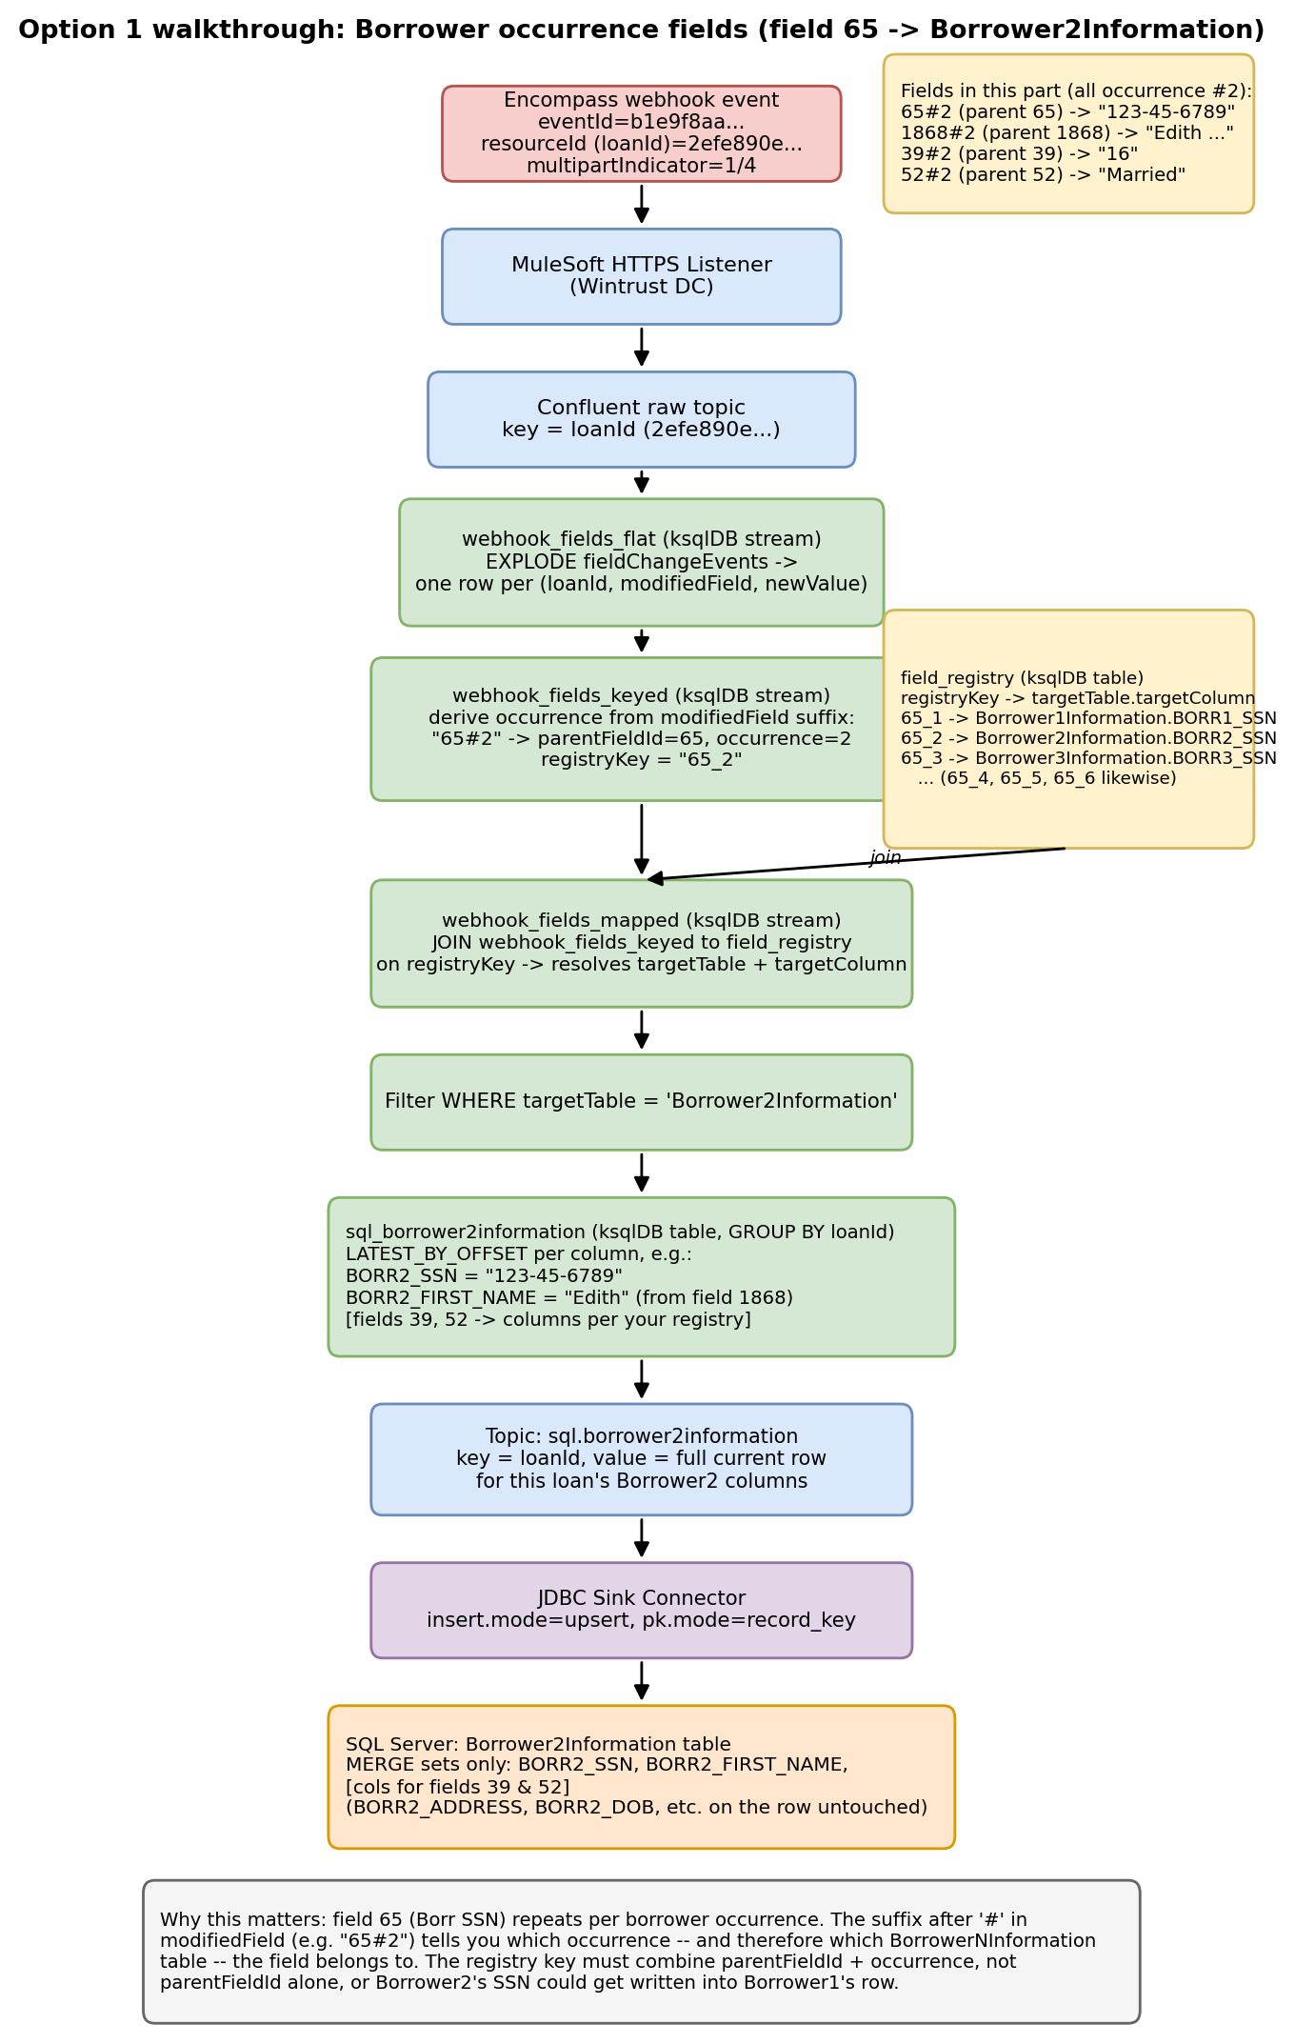

Practical Implementation Walkthrough: Option 2 (SQL Server-side routing)
This walkthrough uses the exact same loan and field changes as the Option 1 walkthrough — loanId 2efe890e-191d-4d85-868e-dc492e53ab55, fields 65 (SSN) and 52 (Marital Status) changing for both borrower 1 and borrower 2 — so the two approaches can be compared directly. Both converge on the same final SQL Server state; they differ in where the field-to-table mapping happens and what triggers the write.

One wrinkle worth stating up front
The raw webhook payload nests all field changes inside one fieldChangeEvents array per event. A plain Kafka Connect JDBC Sink Connector writes one row per Kafka message and cannot itself explode an array into multiple rows. Option 1 solved this with a ksqlDB EXPLODE step. Option 2 avoids adding ksqlDB at all: MuleSoft, which already sits between Encompass and Confluent and already has to parse the HTTP payload, flattens each webhook event into one flat Kafka record carrying the field-change array as a JSON string. No mapping decision happens in MuleSoft — it only reshapes HTTP JSON into a flat record; the array itself is unpacked later, inside SQL Server.

Step 1: Single JDBC Sink Connector and staging table
One connector, generic, with no per-field knowledge — it just lands the flat record as one row per event:
CREATE TABLE dbo.WebhookEvents_Staging (
EventId UNIQUEIDENTIFIER NOT NULL PRIMARY KEY,
LoanId VARCHAR(50) NOT NULL,
EventTime DATETIME2 NOT NULL,
MultipartIndicator VARCHAR(10) NULL,
PayloadJson NVARCHAR(MAX) NOT NULL, -- fieldChangeEvents array, as JSON text
LoadedAt DATETIME2 DEFAULT SYSUTCDATETIME(),
Processed BIT DEFAULT 0
);
Sample output — the one row this event produces in staging:
EventId: b1e9f8aa-1186-4611-a59d-71709cbfb150
LoanId: 2efe890e-191d-4d85-868e-dc492e53ab55
EventTime: 2024-04-03T16:17:14.361Z
MultipartIndicator: 1/1
PayloadJson: [
{"modifiedField":"65", "parentFieldId":"65", "encompass":{"newValue":"111-22-3333"}},
{"modifiedField":"52", "parentFieldId":"52", "encompass":{"newValue":"Single"}},
{"modifiedField":"65#2", "parentFieldId":"65", "encompass":{"newValue":"123-45-6789"}},
{"modifiedField":"52#2", "parentFieldId":"52", "encompass":{"newValue":"Married"}}
]
Processed: 0

Step 2: Explode the JSON array, in SQL Server, via a reusable function
This is SQL Server's equivalent of ksqlDB's EXPLODE — OPENJSON unpacks the array, and the same CASE logic used in ksqlDB derives the occurrence and composite registry key:
CREATE OR ALTER FUNCTION dbo.fn_ExplodeFieldChanges (@PayloadJson NVARCHAR(MAX))
RETURNS TABLE
AS
RETURN
SELECT
ModifiedField,
ParentFieldId,
NewValue,
CASE WHEN CHARINDEX('#', ModifiedField) = 0 THEN ParentFieldId + '_1'
ELSE ParentFieldId + '_' + SUBSTRING(ModifiedField, CHARINDEX('#', ModifiedField) + 1, 10)
END AS RegistryKey
FROM OPENJSON(@PayloadJson)
WITH (
ModifiedField VARCHAR(50) '$.modifiedField',
ParentFieldId VARCHAR(50) '$.parentFieldId',
NewValue NVARCHAR(MAX) '$.encompass.newValue'
);
Sample output — SELECT * FROM dbo.fn_ExplodeFieldChanges(@PayloadJson) for this event's payload:
ModifiedField | ParentFieldId | NewValue | RegistryKey
65 | 65 | 111-22-3333 | 65_1
52 | 52 | Single | 52_1
65#2 | 65 | 123-45-6789 | 65_2
52#2 | 52 | Married | 52_2

Step 3: Field registry (identical shape to Option 1's, just read directly by SQL)
CREATE TABLE dbo.FieldRegistry (
RegistryKey VARCHAR(30) PRIMARY KEY,
TargetTable SYSNAME NOT NULL,
TargetColumn SYSNAME NOT NULL
);
Sample output — the rows this example resolves against:
RegistryKey | TargetTable | TargetColumn
65_1 | Borrower1Information | BORR1_SSN
65_2 | Borrower2Information | BORR2_SSN
52_1 | Borrower1Information | BORR1_MARITAL_STATUS
52_2 | Borrower2Information | BORR2_MARITAL_STATUS

Step 4: The shared logic — one procedure, called two different ways
Both the batch job and the trigger call the same procedure. It explodes and maps the relevant staging rows into a temp table, routes unmapped fields to an exceptions table, then calls a second procedure once per distinct target table to apply the actual write. Only what feeds @EventIds differs between the two callers, shown in Step 5.
CREATE OR ALTER PROCEDURE dbo.usp_ApplyWebhookEvents
@EventIds NVARCHAR(MAX) = NULL -- comma-separated GUIDs; NULL = batch mode, all unprocessed
AS
BEGIN
SET NOCOUNT ON;
SELECT s.EventId, s.LoanId, f.RegistryKey, f.NewValue
INTO #Exploded
FROM dbo.WebhookEvents_Staging s
CROSS APPLY dbo.fn_ExplodeFieldChanges(s.PayloadJson) f
WHERE (@EventIds IS NULL AND s.Processed = 0)
OR (@EventIds IS NOT NULL AND s.EventId IN (SELECT value FROM STRING_SPLIT(@EventIds, ',')));
SELECT e.LoanId, e.EventId, r.TargetTable, r.TargetColumn, e.NewValue
INTO #Mapped
FROM #Exploded e
JOIN dbo.FieldRegistry r ON e.RegistryKey = r.RegistryKey;
INSERT INTO dbo.WebhookFields_Exceptions (EventId, LoanId, RegistryKey)
SELECT DISTINCT e.EventId, e.LoanId, e.RegistryKey
FROM #Exploded e
LEFT JOIN dbo.FieldRegistry r ON e.RegistryKey = r.RegistryKey
WHERE r.RegistryKey IS NULL;
DECLARE @tbl SYSNAME;
DECLARE tbl_cursor CURSOR LOCAL FAST_FORWARD FOR SELECT DISTINCT TargetTable FROM #Mapped;
OPEN tbl_cursor; FETCH NEXT FROM tbl_cursor INTO @tbl;
WHILE @@FETCH_STATUS = 0
BEGIN
EXEC dbo.usp_MergeTargetTable @TargetTable = @tbl;
FETCH NEXT FROM tbl_cursor INTO @tbl;
END
CLOSE tbl_cursor; DEALLOCATE tbl_cursor;
IF @EventIds IS NULL
UPDATE dbo.WebhookEvents_Staging SET Processed = 1
WHERE EventId IN (SELECT DISTINCT EventId FROM #Mapped);
END;
Sample output — #Mapped for this event (0 rows land in WebhookFields_Exceptions, since all four fields are registered):
LoanId | TargetTable | TargetColumn | NewValue
2efe890e... | Borrower1Information | BORR1_SSN | 111-22-3333
2efe890e... | Borrower1Information | BORR1_MARITAL_STATUS | Single
2efe890e... | Borrower2Information | BORR2_SSN | 123-45-6789
2efe890e... | Borrower2Information | BORR2_MARITAL_STATUS | Married

Step 5: Building the dynamic MERGE per table
CREATE OR ALTER PROCEDURE dbo.usp_MergeTargetTable
@TargetTable SYSNAME
AS
BEGIN
SET NOCOUNT ON;
DECLARE @selectCols NVARCHAR(MAX) = (
SELECT STRING_AGG(CONVERT(NVARCHAR(MAX),
'MAX(CASE WHEN TargetColumn = ''' + TargetColumn + ''' THEN NewValue END) AS ' + QUOTENAME(TargetColumn)
), ', ')
FROM (SELECT DISTINCT TargetColumn FROM #Mapped WHERE TargetTable = @TargetTable) c);
DECLARE @colList NVARCHAR(MAX) = (
SELECT STRING_AGG(CONVERT(NVARCHAR(MAX), QUOTENAME(TargetColumn)), ', ')
FROM (SELECT DISTINCT TargetColumn FROM #Mapped WHERE TargetTable = @TargetTable) c);
DECLARE @setClause NVARCHAR(MAX) = (
SELECT STRING_AGG(CONVERT(NVARCHAR(MAX),
QUOTENAME(TargetColumn) + ' = src.' + QUOTENAME(TargetColumn)), ', ')
FROM (SELECT DISTINCT TargetColumn FROM #Mapped WHERE TargetTable = @TargetTable) c);
DECLARE @sql NVARCHAR(MAX) = N'
MERGE ' + QUOTENAME(@TargetTable) + N' AS tgt
USING (SELECT LoanId, ' + @selectCols + N' FROM #Mapped
WHERE TargetTable = ''' + @TargetTable + N''' GROUP BY LoanId) AS src
ON tgt.LoanId = src.LoanId
WHEN MATCHED THEN UPDATE SET ' + @setClause + N'
WHEN NOT MATCHED THEN INSERT (LoanId, ' + @colList + N')
VALUES (src.LoanId, ' + @colList + N');';
EXEC sp_executesql @sql;
END;
Guardrail worth calling out: @TargetTable and @TargetColumn only ever come from rows you loaded into FieldRegistry — never from the raw payload directly. Validate registry rows against sys.tables / sys.columns when they're loaded (e.g. from the Excel mapping) so a typo can't silently build a MERGE against a nonexistent or wrong object; this is what keeps the dynamic SQL safe despite table/column names being assembled at runtime.
Sample output — the actual SQL text @sql resolves to for each table in this example (captured via PRINT @sql for illustration; sp_executesql runs this, it is not saved anywhere):
-- @TargetTable = 'Borrower1Information'
MERGE Borrower1Information AS tgt
USING (SELECT LoanId,
MAX(CASE WHEN TargetColumn = 'BORR1_SSN' THEN NewValue END) AS [BORR1_SSN],
MAX(CASE WHEN TargetColumn = 'BORR1_MARITAL_STATUS' THEN NewValue END) AS [BORR1_MARITAL_STATUS]
FROM #Mapped WHERE TargetTable = 'Borrower1Information' GROUP BY LoanId) AS src
ON tgt.LoanId = src.LoanId
WHEN MATCHED THEN UPDATE SET [BORR1_SSN] = src.[BORR1_SSN], [BORR1_MARITAL_STATUS] = src.[BORR1_MARITAL_STATUS]
WHEN NOT MATCHED THEN INSERT (LoanId, [BORR1_SSN], [BORR1_MARITAL_STATUS])
VALUES (src.LoanId, src.[BORR1_SSN], src.[BORR1_MARITAL_STATUS]);
-- @TargetTable = 'Borrower2Information' (structurally identical, different table/values)

Step 6: Two ways to invoke it, side by side
 | Micro-batch (SQL Agent Job) | Trigger (AFTER INSERT)
Invocation code | EXEC dbo.usp_ApplyWebhookEvents;  (runs on a schedule, e.g. every 15s) | Fires automatically inside the same  transaction as the staging INSERT
Latency | Up to the poll interval (seconds) | Effectively immediate
Overhead | One set-based pass over a small batch | Cursor + dynamic SQL run on every  single insert, even single-row inserts
Failure isolation | A bad batch can be paused/rerun  without blocking new inserts | A failure inside the trigger rolls back  the staging insert itself
Operational visibility | Easy: query Processed = 0 to see backlog | Harder: no natural backlog to inspect
Trigger code (the only genuinely different piece — everything it calls is identical to the batch path):
CREATE OR ALTER TRIGGER trg_WebhookEvents_Staging_Insert
ON dbo.WebhookEvents_Staging
AFTER INSERT
AS
BEGIN
SET NOCOUNT ON;
DECLARE @ids NVARCHAR(MAX) = (
SELECT STRING_AGG(CONVERT(NVARCHAR(MAX), CAST(EventId AS VARCHAR(36))), ',')
FROM inserted);
EXEC dbo.usp_ApplyWebhookEvents @EventIds = @ids;
END;
Batch job step (the entire difference on this side is that it's scheduled, not fired by an insert):
-- SQL Agent Job step, schedule: every 15 seconds
EXEC dbo.usp_ApplyWebhookEvents; -- @EventIds defaults to NULL

Final state — identical regardless of which path ran
Sample output — both approaches produce the same two SQL Server rows (columns not shown, e.g. BORR1_FIRST_NAME, BORR1_DOB, are left exactly as they were):
Table | LoanId | SSN column | Marital status column | Other columns
Borrower1Information | 2efe890e... | 111-22-3333 | Single | (untouched)
Borrower2Information | 2efe890e... | 123-45-6789 | Married | (untouched)
This is the same final state the Option 1 walkthrough reached for the same loan — useful to point out in the brainstorm, since it shows the choice between options is genuinely about latency, operational fit, and where the team's skill sits, not about correctness or capability.
Diagram: end-to-end flow, both invocation paths
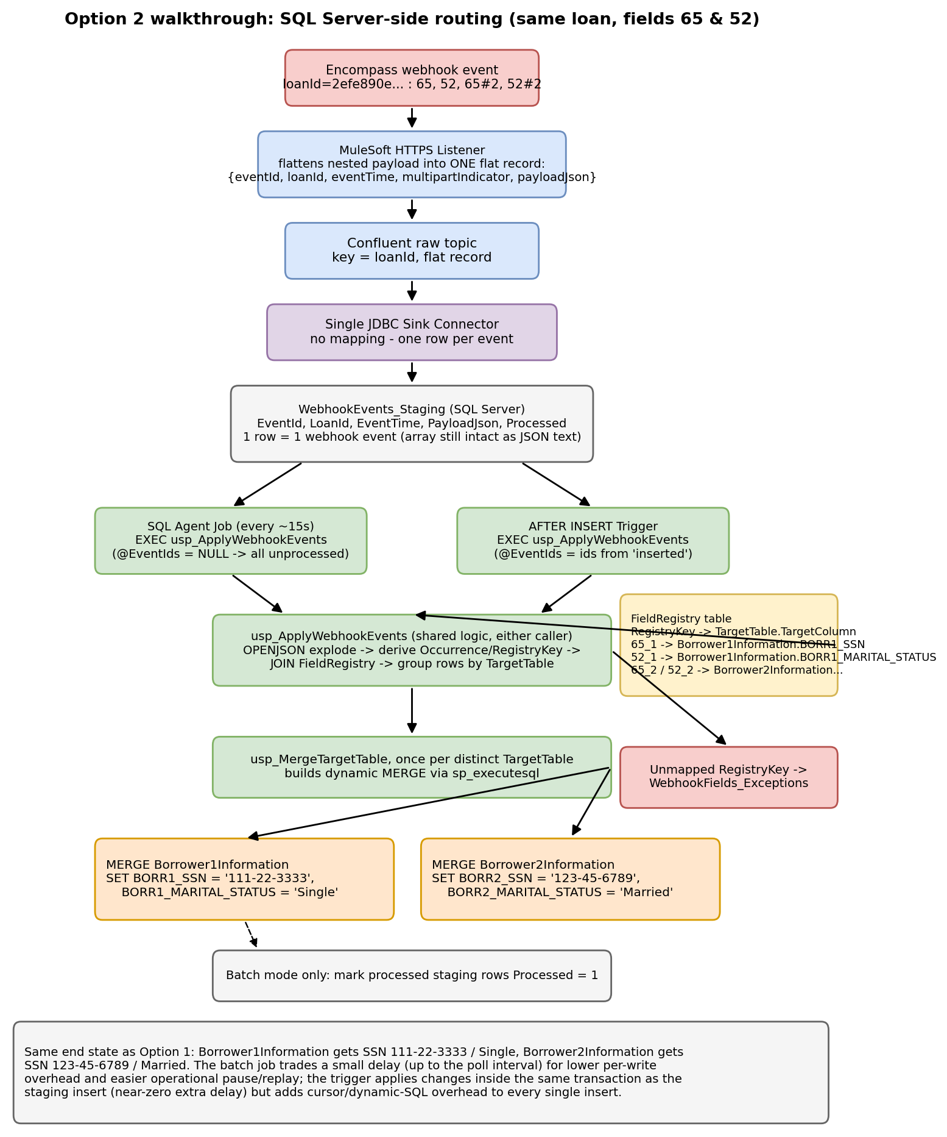

Open questions for the brainstorm
- Expected event volume/frequency across all 16 banks — does this favor streaming-native scaling (Option 1) or is micro-batch (Options 2/3) comfortably sufficient?
- Team's current comfort with Kafka Streams/ksqlDB vs. T-SQL vs. Python — which skill set is deepest today, and which is worth investing in regardless of this decision?
- Does adding a new always-on service (Option 3, if not run via Stonebranch) fit existing ops/monitoring standards, or is it a harder sell than extending Kafka Connect or SQL Agent?
- How firm is the Couchbase timeline — does it change which option is easiest to extend first?
- Failure/retry strategy with Encompass (still TBD with vendor per the SRS) — does the chosen option need to handle webhook redelivery differently?

